Model European Union Conference: A Charter of Digital Fundamental Rights of the EU

The Position of the Kingdom of Belgium on the Charter of Digital Fundamental Rights of the European Union

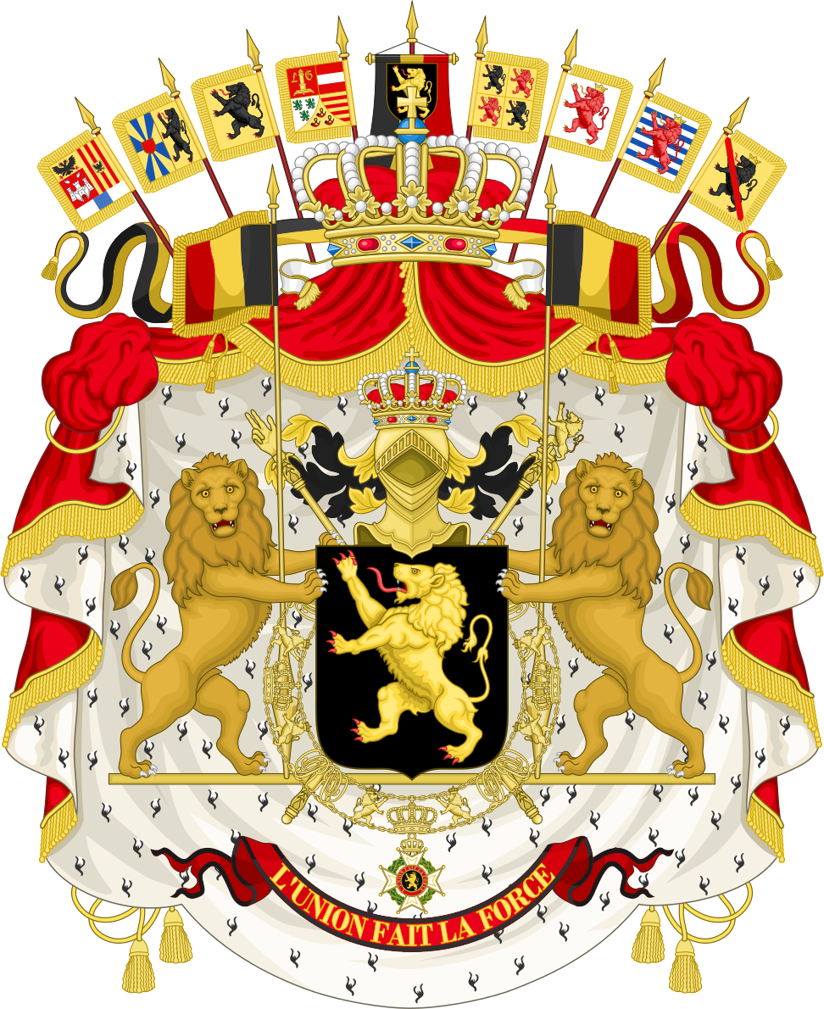

Nina Hermus
Caroline Weber

Introduction

We, The Kingdom of Belgium, strongly support the creation of a Charter of Digital Fundamental Rights of the European Union. The digital age has arrived and cannot be stopped anymore. Never in humankind has it been so easy for so many people to get information. The development of telecom networks and internet devices is undeniable. Currently 3 billion people have access and are connected to the internet. In the near future this number will highly increase, by the striving of networking companies, until all 7 billion people are reached. The fundamental question is whether our fundamental rights, as we previously understood them and how they are interpreted by the different national courts, are strong enough to further protect to collective and individual right of self-determination, so that the people of the European Union enjoy the same protection in the digital world as in the analogue world. Therefore this “New Digital Age” has to go hand in hand with corresponding fundamental rights, that protects the European population. The current Constitutions of the Member States, however, do not possess an adequate protection regarding the rights and freedoms that fall under this “Digital Era”. Therefore we, the Kingdom of Belgium, are stimulating the development of the Charter of Digital Fundamental Rights of the European Union in order to provide an adequate protection for the people of the European Union.

Critics and propositions

Article 1 (2) - The first article is only an enumeration of problems that can lead to a the violation of human dignity. The Charter should, however, be a regulation and not listing problems without saying what is right or wrong with those specific actions. The consequence of those problems is not explained. This part of the article is not structured like law.
Article 1 (3) - Special emphasis needs to be put on the scope of the Charter of Digital Fundamental Rights. Because of the profound transformation process, as what we call the “New Digital Era”, more governmental functions and tasks are being privatised. Big companies, such as Facebook, Google or Twitter have a big influence on the daily life of the European citizens. Therefore not only a vertical direct effect, between States and individuals, has to be acknowledged in the Charter, but also the horizontal effect, between private individuals. Although both States and individual parties are already written down as addressees, the scope of the Charter has to be widened out. We, the Kingdom of Belgium, are of the opinion that the European Union also has to be formally acknowledged as one of the addressees of the Charter. The Charter of Digital Fundamental Rights is in the first place a legal document of the European Union and therefore the European Union and its institutions should be the first party to be formally recognized as one of the addressees.
Article 5 (2) - The Charter of Digital Fundamental Rights is a legal document, granting legal rights and freedoms. The concepts of “Digital harassment, mobbing and activities likely to pose a serious threat to the reputation or physical integrity of a person” should therefore be avoided, while these notions are not legal concepts and are formulated in such manner that could give rise to discussion. The right of freedom of speech and expression, as in the freedom to hold opinions and to receive and impart information and ideas without interference by public authority and regardless of frontiers, is recognized in different international and regional human rights law. Although this right is not an absolute right without any restrictions, it remains one of the core freedoms of our democratic society. Especially for the media and publishing, it’s of crucial importance that we have to decide where the line is between digital harassment and mobbing, and freedom of expression. The concepts used in the Charter of Digital Fundamental Rights should be made more clear, so that there is less room for interpretation and discussion.
Furthermore, this part is a contradiction to the first section of the article. Mobbing for example, can only be prevented in censoring some comments or posts. At the moment it is common, that Facebook, for example, is deleting some opinions that are discriminating other groups, especially in the form of racism. We have the opinion that when some groups are discriminating, or when groups are planning online to commit crimes, that in these cases those opinions should indeed be censored.
Article 11 - We, the Kingdom of Belgium, have the opinion that article 11 lacks a significant meaning in the whole of the Charter of Digital Fundamental Rights. The General Data Protection Regulation (Regulation (EU) 2016/679) is the binding regulation, set out by the European Parliament, the Council of the European Union and the European Commission for the unification of data protection within the European Union. This regulation will enter into force on 25th of May 2018. Dedicating an article in the Charter to data protection and data sovereignty will miss its effect while a broader, more detailed regulation on this matter is already agreed upon. We therefore suggest to make a reference of acknowledgment in the preamble to the General Data Protection Regulation and to take article 11 out of the Charter of Digital Fundamental Rights.
Article 19 – Article 19 is about fostering the participation of Children, adolescents and disadvantaged people. This indicates that their participation in this Digital Era should be more supported. From our point of view, it is not a good idea to let younger people participate even more in this Digital Era than now. Young children are starting using internet platforms at a very young age and this does not only includes benefits. Concentrating at school will become even more of a problem due to a massive use of phones and computers that is transferring them into another world. Apart from this concentration issue, younger people do not see the dangers of putting their private details online. This is dangerous, as lots of criminals are active on the internet and are also using fake accounts. Certainly, at school, the students can be educated on how to use internet platforms in the right way. To support them in their participation is however exaggerated and inadequate, as the youth already does so and should not use those digital technologies even more than they do now.
Art. 2, Art. 5, Art. 9, Art. 10, Art. 21 are not giving any new aspects compared to our Belgium constitution. Those articles are already a part of the European Fundamental Rights Charter as well. It is unnecessary to write the same articles in the Digital Charter again. It is just a repetition of already established law. In consequence, we have the opinion that those articles should be completely removed from the Charter.

- Conclusion
In conclusion, the Kingdom of Belgium has a lot of critical aspects on the Charter of Digital Fundamental Rights of the European Union. Nevertheless, the idea of developing new laws in this “New Digital Era” should be supported. We encourage the making of new laws, like Article 12, which has not been regulated yet. Other articles, on the other hand, are not useful or specific enough. Therefore, it is necessary to rework the Charter of Digital Fundamental Rights.

Article 10 of European Convention on Human Rights, Article 19 of the Universal Declaration of Human Rights, Article 11 of the Charter of Fundamental Rights of the European Union,

